PROJECT REPORT

Bench Marking different Classification Methods

Prepared by Group 7: Dinesh Arasavalli

Abstract

This report presents a detailed description of comprehensive evaluation of seven classification methods applied to 20 diverse datasets using R. As different models perform in unique and distinct ways on the same dataset, we all know different models have different methods to categorize input data based on data structure, categorical predictors, and type of variables so we can expect distinct differences in output variables and performance parameters or metrics For Model evaluation parameters/metrics, we are considering two parts training and testing, As different models have different input training metrics, but for testing parameters, we are considering ROC, AUC, run time, confusion matrix,f1 value, accuracy and precision. An averaging is done for the value of 20 iterations for accuracy, precisions and moreover using same set of metrics for all classification models will greatly help during comparison. The datasets that are gathered, are from different online sources: Kaggle, UCI machine learning repository, and GitHub, For the project, we considered a few health or disease-related datasets through which we can predict the possibilities of that disease, a few datasets are related to credit loans, loan data and some datasets related automotive and wine quality.

Background and significance
Classification algorithms in machine learning are a subset of supervised learning techniques used to identify the category or class to which a new observation belongs, based on a training set of data containing observations whose category membership is known. These algorithms analyze the input data and use learned relationships to categorize new observations into predefined classes. They are used for their ability to simplify complex decision-making processes by categorizing data into distinct classes. This is crucial in many fields, such as medical diagnosis, where algorithms can help identify disease categories based on symptoms and tests, or in finance, where they can categorize transactions as fraudulent or legitimate.
There are a wide range of classification models, each with its strengths and weaknesses. Common models include logistic regression, which is used for binary classification; decision trees, which are easy to interpret; random forests, an ensemble method that improves on the simplicity of decision trees; support vector machines, known for their effectiveness in high- dimensional spaces; and neural networks, which are particularly useful for complex, non-linear relationships.

In our study, we focus on benchmarking seven distinct classification methods across twenty diverse datasets. These methods are selected for their popularity and diverse algorithmic approaches. The datasets, sourced from public domains, encompass a wide range of sectors and complexities, ensuring a comprehensive evaluation platform. The primary objective of our benchmarking is to evaluate whether different classification methods perform differently on the same datasets. By doing so, we aim to shed light on the suitability of each method for various types of data. This involves assessing the performance of each algorithm in terms of metrics such as accuracy, precision, recall, F1 score, and area under the ROC curve (AUC).

Datasets
The table below shows all the 20 datasets we have taken for our benchmarking purposes from different public domains, mostly from Kaggle and University of California-Irvine (UCI) Machine Learning Repository and one from ISLR. The datasets cover diverse topics like Finance, Healthcare, Education, Social sciences etc. which vary in size, nature and complexity. The table below contains information of the names of datasets, N value which denotes the number of instances, P value which denotes the number of columns also predictor variables along with sources and links for the datasets.

Table:

Data set Names | Classification | No. Of instances(  N) | No. Of col (P) | Source & Link
Loan data | Loan eligbility | 614 | 11 | Kaggle https://www.kaggle.com/datasets  /burak3ergun/loan-data-set
Liver_patient | Prediction for liver disease | 583 | 10 | UCI  https://archive.ics.uci.edu/dataset  /225/ilpd+indian+liver+patient+da  taset
stroke | Prediction for Brain disease | 4932 | 10 | Kaggle https://www.kaggle.com/datasets  /shashwatwork/cerebral-stroke-  predictionimbalaced-dataset
diabetes | Diabetes prediction | 768 | 8 | Kaggle https://www.kaggle.com/datasets  /uciml/pima-indians-diabetes-  database
Heart_attack | Prediction of heart stroke | 302 | 13 | Kaggle https://www.kaggle.com/datasets  /rashikrahmanpritom/heart-  attack-analysis-prediction-dataset
Breast_cancer | Prediction for Breast cancer  wiscosin | 569 | 32 | UCI  https://archive.ics.uci.edu/dataset  /17/breast+cancer+wisconsin+dia  gnostic
Wine_quality | Wine quality predictions | 1600 | 12 | UCI  https://archive.ics.uci.edu/dataset  /186/wine+quality
default | Credit card Yes or  no/student | 10000 | 3 | ISLR  https://rdrr.io/cran/ISLR/man/Def  ault.html
diabetes2 | Prediction for diabetes | 520 | 16 | Kaggle https://www.kaggle.com/datasets  /andrewmvd/early-diabetes-  classification

Heart_failure | Post-surgery heart failure prediction | 299 | 13 | UCI  https://archive.ics.uci.edu/dataset  /519/heart+failure+clinical+record  s
Student_data | Academic success and dropout  prediction | 4424 | 37 | UCI  https://archive.ics.uci.edu/dataset  /697/predict+students+dropout+a  nd+academic+success
Cell_samples | Prediction of classification of cell samples into  2 types | 700 | 11 | Github https://github.com/kvinlazy/Datas et/blob/master/cell_samples.csv? plain=1
New_model | Prediction for kidney disease | 400 | 14 | Kaggle https://www.kaggle.com/datasets  /abhia1999/chronic-kidney-  disease
Metabolic syndrome | Presence or absence of metabolic  syndrome | 2401 | 15 | Kaggle https://www.kaggle.com/datasets  /antimoni/metabolic-syndrome
gbsg | Breast cancer prediction yes/no | 686 | 12 | Kaggle https://www.kaggle.com/datasets  /utkarshx27/breast-cancer- dataset-used-royston-and-altman
drug200 | Classification of drugs into certain types | 200 | 6 | Github https://github.com/kvinlazy/Datas et/blob/master/drug200.csv
babies | Classification whether the baby’s mom does smoke/not  smoke | 1237 | 8 | Kaggle https://www.kaggle.com/datasets  /debjeetdas/babies-birth-weight
Disease_sypto m_and_patien t | Prediction of diagnosis/ass essment of specific  disease | 349 | 10 | Kaggle https://www.kaggle.com/datasets  /uom190346a/disease-symptoms- and-patient-profile-dataset

Rice_classifica tion | Rice grain type prediction | 18186 | 11 | Kaggle https://www.kaggle.com/datasets  /mssmartypants/rice-type- classification
heart | Prediction of heart disease | 919 | 12 | Kaggle https://www.kaggle.com/datasets  /j ohnsmith88/heart-disease-  dataset

Methodology
In this study, we benchmark seven classification models using R: Generative models such as LDA, QDA, Naïve bayes were selected for their ability to estimate class-specific data distributions and discriminative models like Logistic regression, support vector machines and decision trees, which are adept at creating decision boundaries to distinguish between different classes. The primary selection criteria were the model's effectiveness in handling linearly
separable data. A brief description of the model’s functionality is listed below.

Generalized Linear Model (GLM) - Stats Package: glm()
GLM extends the traditional linear regression model by allowing for response variables that have error distribution models other than a normal distribution. It is particularly useful for modeling binary outcomes (as in logistic regression) or count data, among other types. By linking a function of the mean of the response variable to the predictors, GLM provides a flexible framework for analyzing diverse types of data.

Linear Discriminant Analysis (LDA) - MASS Package: lda()
LDA is a well-established method for dimensionality reduction and classification, which works by maximizing the separation between multiple classes through linear decision boundaries. This technique is particularly effective in scenarios where simplicity and computational efficiency are as important as predictive accuracy.

Quadratic Discriminant Analysis (QDA) - MASS Package: qda()

QDA extends the capabilities of Linear Discriminant Analysis by allowing for quadratic decision boundaries, making it more suitable for datasets where the class distribution is non-linear. This method enhances the model's adaptability to varying covariance structures among different classes, thus offering a more flexible approach in complex classification scenarios.

K-Nearest Neighbours (KNN) - Class Package: knn()
KNN is an instance-based learning method where the classification of a new observation is determined based on the majority class among its 'k' nearest neighbors in the feature space. This method is particularly valued for its simplicity and effectiveness, especially in cases where the data exhibits non-linear patterns.

Naive Bayes - e1071 Package:
Naive Bayes is a probabilistic classifier operates on the principle of Bayes' theorem, with the assumption that the predictors are independent of each other given the class. Despite its simplicity, Naive Bayes is known for its efficiency and effectiveness, especially in text classification and scenarios with high-dimensional data.

Support Vector Machine (SVM) - e1071 Package: svm()
VM is renowned for its effectiveness in both linear and non-linear classification, achieved through the use of kernel functions to transform the data into a higher-dimensional space. This method excels in handling complex and high-dimensional datasets, making it a robust tool for diverse classification challenges.

Random Forest - RandomForest Package: randomForest()
It is implemented for decision tree-based ensemble learning. It constructs multiple decision trees during training and outputs the class that is the mode of the classes of the individual trees. This method is well-regarded for its ability to handle large datasets with high dimensionality and its robustness against noise and overfitting

Model Parameters

Model | Training | Testing

Logistic Regression glm() | Time, Error rate | Accuracy, precision, ROC, AUC, Confusion matrix, Run  time, F1 score
Linear discriminant analysis lda() | Time, Error rate | Accuracy, precision, ROC, AUC, Confusion matrix, Run time, F1 score
Quadrant discriminant analysis qda() | Time, Error rate | Accuracy, precision, ROC, AUC, Confusion matrix, Run time, F1 score
randomForest | Time, Error rate | Accuracy, precision, ROC, AUC, Confusion matrix, Run time, F1 score
Support vector machine svm() | Time, Error rate | Accuracy, precision, ROC, AUC, Confusion matrix, Run time, F1 score

Model | Testing
K nearest Neighbour | Accuracy, precision, ROC, AUC, Confusion matrix, Run time, F1 score
Naive Bayes | Accuracy, precision, ROC, AUC, Confusion matrix, Run time, F1 score

Data Cleaning
Our main focus is on converting target or label columns into a binary format (0 or 1), which simplifies the datasets for binary classification tasks. Additionally, we did identify and remove specific columns considered non-predictive or irrelevant to the analyses, ensuring a more

focused dataset. The script also cleans the datasets by eliminating rows(non- predictive/irrelevant) with missing values in key columns, thereby enhancing data quality and consistency. Finally, each processed dataset is saved in a designated directory named Processed data, facilitating easy access and use for subsequent analysis or modelling tasks.

Here is the code snippet for the cleaning:

Data Analysis and Visualization:
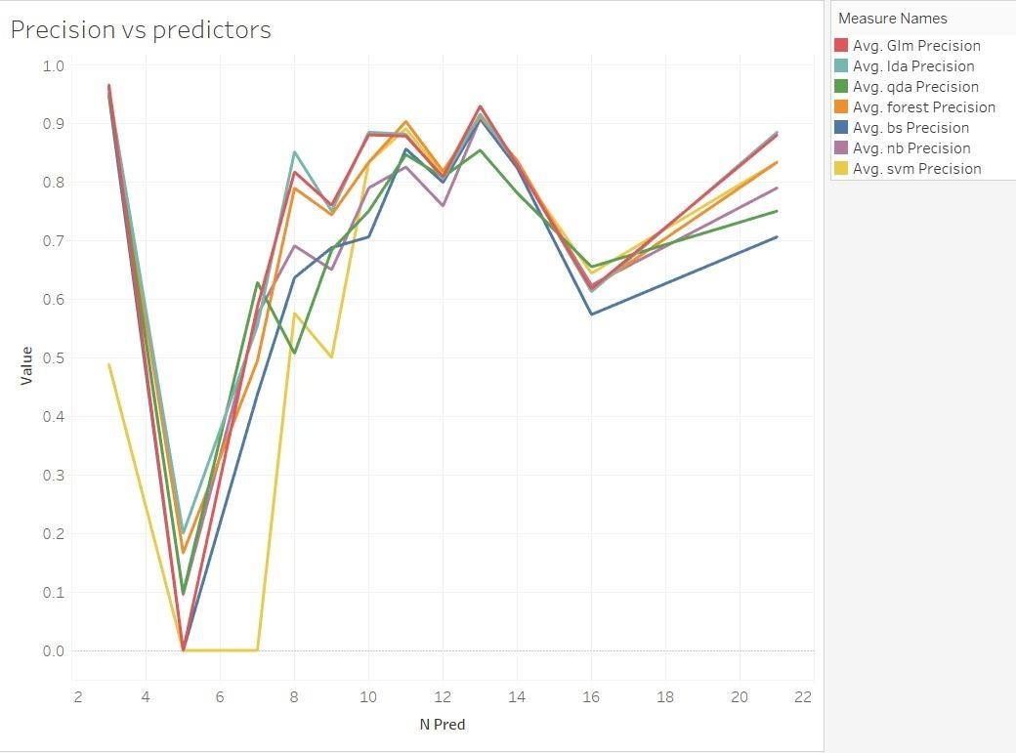

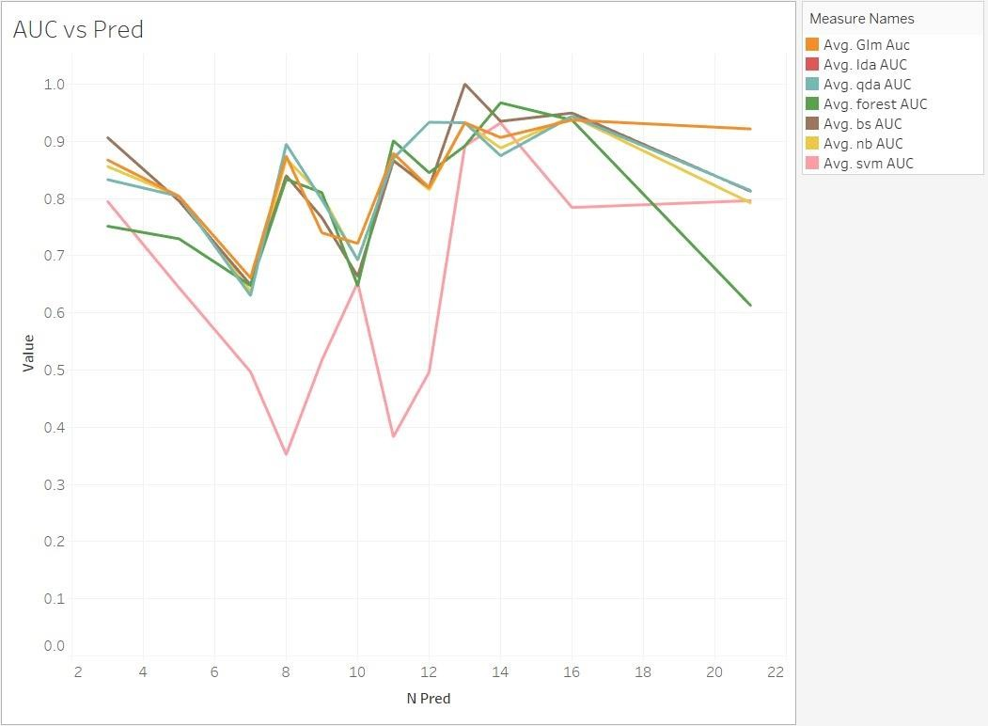

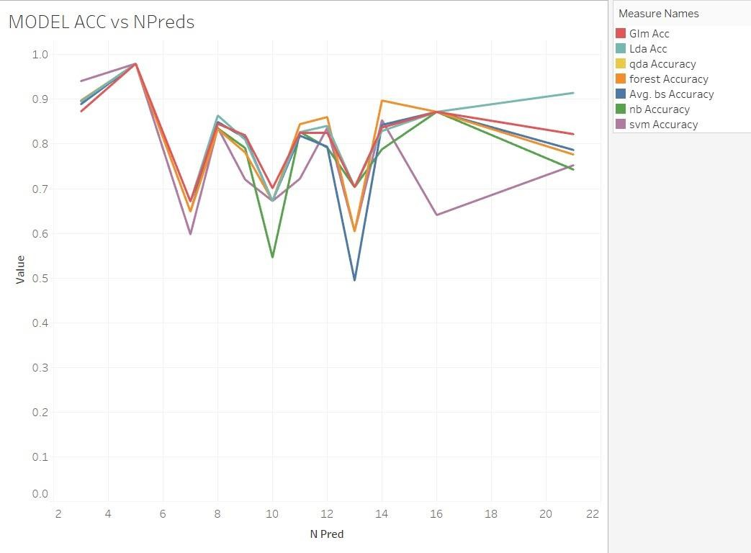

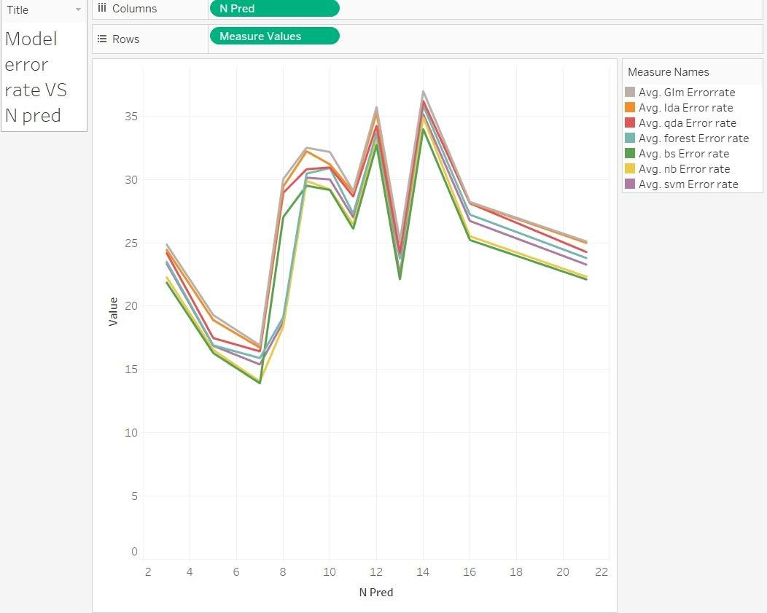

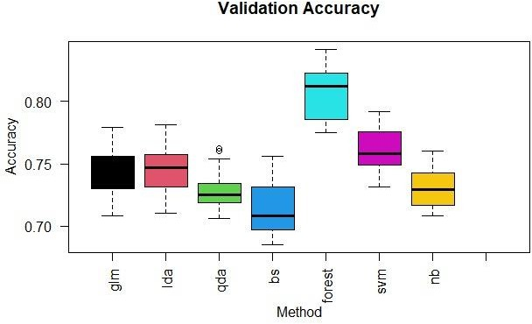

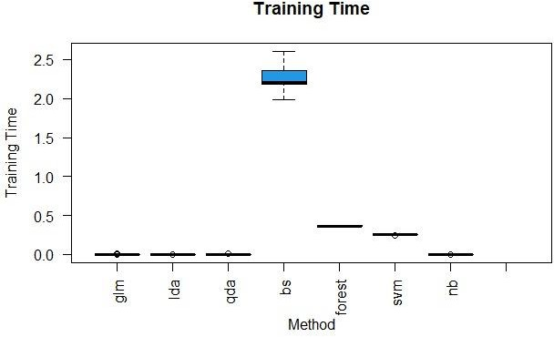

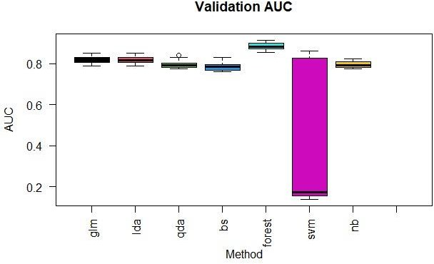

Model Metrics

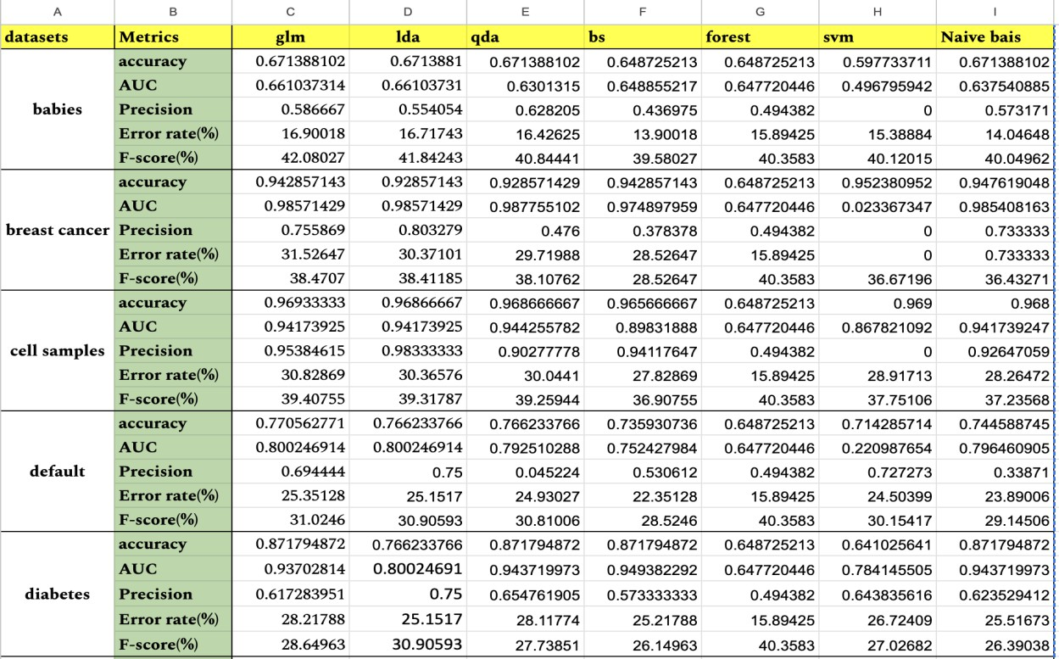
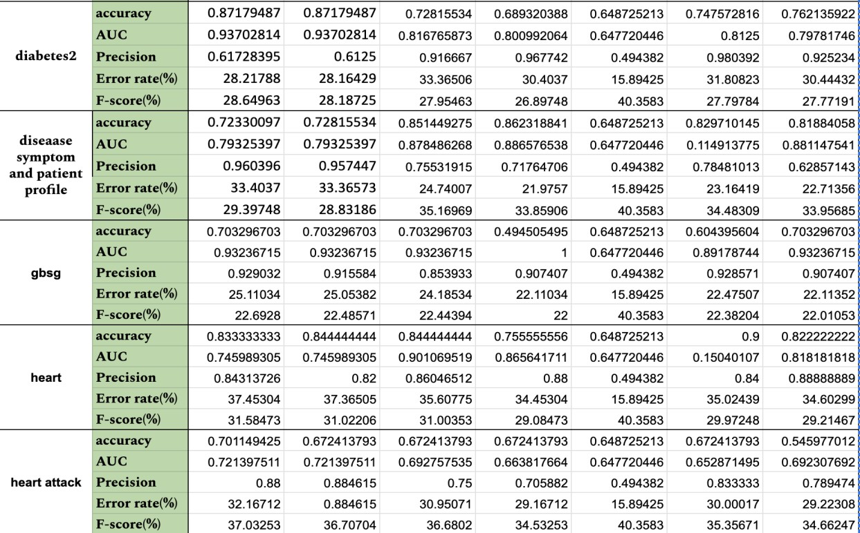

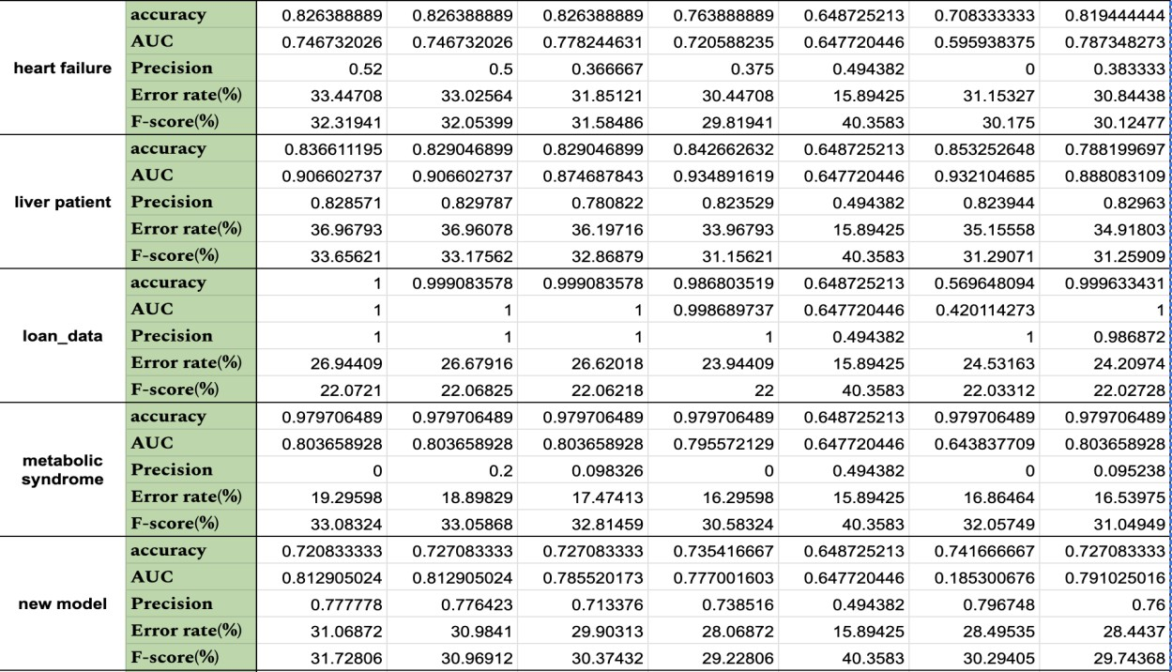
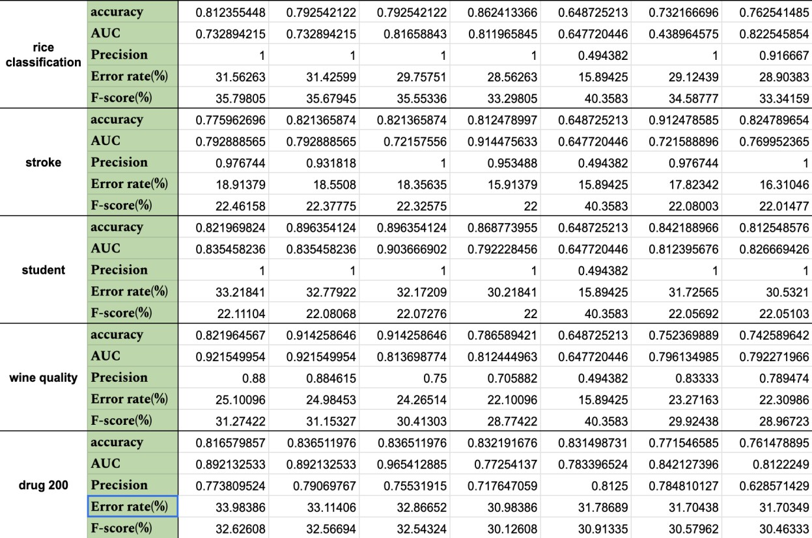
Benchmarked Metrics

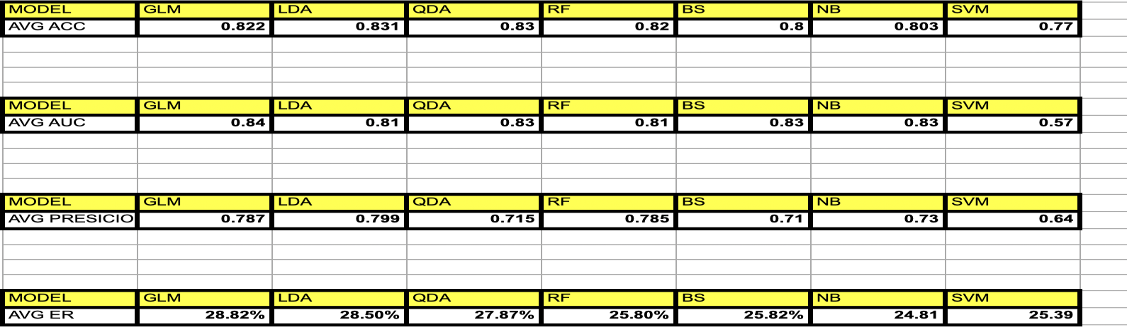

Evaluating Differences and Model Metrics: The evaluation process involves splitting each dataset into a training set (70%) and a test set (30%). Each classification method is applied to these datasets, and its performance is measured using the aforementioned metrics.
Furthermore, we implement method-specific parameter tuning through cross-validation on the training set to optimize each model's performance. This dual evaluation—before and after optimization—allows us to comprehensively assess the out-of-the-box efficiency of the algorithms as well as their potential when fine-tuned.

Significance of Our Study: Our study is significant as it provides empirical evidence on the performance of various classification methods across multiple datasets, helping practitioners make informed decisions about algorithm selection based on specific data characteristics. This benchmarking exercise not only contributes to the theoretical understanding of these methods but also offers practical insights into their real-world applicability.

Conclusion
The line graph depicts a comparison of various predictive models' accuracies across a series of predictions. One model demonstrates the highest accuracy, peaking above the others, while another model shows the lowest, dipping below the rest at certain points. Overall trends suggest that some models' accuracies fluctuate significantly with the number of predictions, indicating variability in performance. The specific model names and their corresponding accuracy levels at different prediction counts are color-coded for easy identification.

References
- James, Witten, Hastie and Tibshirani, An Introduction to Statistical Learning with Applications in R (ISLR).
- Provost and Fawcett, Data Science for Business (DSFB) - What You Need to Know about Data Mining and Data-Analytic Thinking, O’REILLY, 2013.
- https://www.rdocumentation.org/
- The Comprehensive R Archeive network: https://cran.r-project.org/
- https://www.projectpro.io/article/7-types-of-classification-algorithms-in- machine-learning/435
- https://www.simplilearn.com/tutorials/machine-learning-tutorial/classification- in-machine-learning
- https://www.ncbi.nlm.nih.gov/pmc/articles/PMC8306704/

